 |  |  | Sharps Copse Primary School  Prospect Lane  HAVANT  Hants  PO9 5PE
Educational
Trips & Visits Policy
2024 – 2027
 |  | Date: |  |  | Jan 2024
 |  | Review Date: |  |  | Jan 2027
 |  | Responsibility: |  |  | Headteacher
 |  | Statutory, recommended or additional: |  |  | Recommended
 |  | Checked against Equalities Policy: |  |  | Yes
 |  | Linked Documents: Complaints Procedure and Data Protection, Health & Safety, Behaviour, Special Educational Needs, Charging & Remissions, Minibus, School Debt, Child Protection, Safeguarding, Whistle Blowing Policies and current Keeping Children Safe in Education (KCSiE) document
 |  | Chair of Governors: Mrs J. Towers |  |  | Date: Jan 2024
 |  | Headteacher: Mr M. Elsen |  |  | Date: Jan 2024

1. Introduction

Educational visits are activities arranged by or on behalf of Sharps Copse Primary School, which take place outside the school grounds. The governors and teaching staff believe that educational visits supplement and enrich the curriculum of the school by providing the children with experiences and opportunities which would otherwise be inaccessible. All educational visits must serve an educational purpose to enhance and enrich our children’s learning experiences.

Sharps Copse Primary School seeks to establish a clear and coherent structure for the planning and evaluation of our educational visits, and to ensure that any risks are managed and kept to a minimum for the safety and health of children, staff and volunteer helpers at all times. Within these limits we aim to make our educational visits available to all children, and wherever possible to make them accessible to those with disabilities. The educational visits usually take place within the school day.

All staff have a statutory obligation to follow and co-operate with the requirements of this policy.

Breach or failure to observe the provisions of this document may lead to action being taken under the School Disciplinary Procedure, located in the school’s policy file retained in the bookcase outside the admin office, electronically on the schools teachers’ network (ADMIN - Policies) and the electronic model copy in the Educational Personnel Services (EPS) Manual of Personnel Practices located at https://hants.gov.uk/educationandlearning, a hard copy is also available on request from the admin office.

This procedure is issued in draft form to all staff and governors for review, consultation, advice and whole school ownership purposes before ratification, approval and finalisation by the Schools Governing Body.

2. Aims

The aim of our educational visits are to:

- enhance curricular and recreational opportunities for our children;
- provide a wider range of experiences for our children than could be provided on the school site alone;
- promote the independence of our children as learners, and enable them to grow and develop in new learning environments.

These educational visits begin with short excursions into the local area in the Early Years progressing to a wider field through to Years 6; 5 and 4 children who are invited to attend a residential experience.

3. Curriculum links

For each subject in the curriculum there is a corresponding programme of activities (which include visits to the school by specialists). All these activities are in line with guidance published and supported by Hampshire County Councils (HCCs) Outdoor Education, PE and Sport Service.

Link |  | Activity | Purpose
English |  | theatre visits, visits by authors, poets and theatre groups | To enhance our school curriculum and to give our children new opportunities and experiences
Science |  | use of the school grounds, visits to botanical gardens | To enhance our school curriculum and to give our children new opportunities and experiences
Mathematics |  | use of shape and number trails in the local environment | To enhance our school curriculum and to give our children new opportunities and experiences
History |  | castle visits, study of local housing patterns, local museums | To enhance our school curriculum and to give our children new opportunities and experiences
Geography |  | use of the locality for fieldwork, village trails | To enhance our school curriculum and to give our children new opportunities and experiences
Art & Design |  | art gallery visits, use of the locality | To enhance our school curriculum and to give our children new opportunities and experiences
PE |  | a range of sporting fixtures, extra-curricular activities, visits by specialist coaches | To enhance our school curriculum and to give our children new opportunities and experiences
Music |  | a variety of specialist music teaching, extra-curricular activities, local schools’ orchestra, concerts for parents to hear | To enhance our school curriculum and to give our children new opportunities and experiences
Design & Technology |  | visits to local factories or design centres | To enhance our school curriculum and to give our children new opportunities and experiences
ICT |  | its use in local shops/libraries/secondary schools etc, | To enhance our school curriculum and to give our children new opportunities and experiences
RE |  | visits to local centres of worship, visits by local clergy | To enhance our school curriculum and to give our children new opportunities and experiences
PHSE |  | visit to the fire station or an old people's residential home, visits by local police officers and health workers | To enhance our school curriculum and to give our children new opportunities and experiences

4. Residential activities

Year 4 children are offered a one night residential stay within the school grounds – this would usually be in a tent. We undertake this visit only with the approval of HCCs Outdoor Education, PE and Sport Service and qualified ‘Camping on your School Grounds’ trained staff are supervising.

Most of our educational staff at Sharps Copse received ‘Camping on your School Grounds’ training TBC; details can be located on the Evolve system retained in reports.

Children in Year 6 are offered a residential visit annually at a location within a 40min travel radius during the Autumn term. We undertake this visit only with the approval of HCCs Outdoor Education and PE and Sport Service.

Parents and carers must agree to the charges and pay in full before their child(ren) participates. The school subsidises these events using Pupil Premium Funding, and a non-refundable deposit is usually required at planning stages to secure the placement. A payment plan will be offered to all parents and carers to help spread the costs in advance.

Sharps Copse Primary School will in all instances where children are attending residential visits, support the costs for hiring coaches to transport children and their luggage to the intended venue; these additional costs will not be passed onto parents or carers (supported by Pupil Premium funding).

5. How visits and activities may be authorised

The headteacher will appoint a group leader/trip organiser to be responsible for running the activity or visit who will usually be a teacher employed at the school. We recognise that it is not good practice for an NQT to be delegated as a visit leader.

At Sharps Copse Primary School, the headteacher has appointed the Year Leaders, Assistant Headteacher (SEND) and PE Co-ordinator to have overall responsibility for educational visits and trips in their phase or team. This will include the completion and evaluation of HCC Evolve forms, risk assessments, mauve trip planner (see attached Appendix I), transport and venue bookings, entering details into school diary and any other details obtained that are applicable to the visit.

Help sheets to access and use the EVOLVE system have been created and are attached as Appendix II. This is also available to view on the teachers’ network or schools website by

visiting www.sharpscopseprimary.co.uk or on request in hardcopy format from the school office.

The schools’ Year Leaders or Assistant Headteacher (SEND) have overall responsibility to ensure that these procedures are being carried out by the group leader/trip organiser within the team who has been delegated to carry out this task.

The school’s educational visits coordinator (EVC) will be involved in the planning and
management of educational visits and trips.

This will include:

- ensuring that risk assessments are completed;
- supporting the headteacher and governing body in their decisions on approval;
- assigning competent staff to lead and help with activities and visits;
- organising related staff training;
- linking with the school Business Manager, verifying that all accompanying adults, including private car drivers, have had satisfactory police checks if required, and that the letter from coach companies assures us their drivers too have had police checks;
- ensuring that all necessary permissions and medical forms are obtained and have been checked by the Year Leader, Assistant Headteacher (SEND), PE Co-ordinator or other delegated staff;
- Keeping records of visits using HCCs EVOLVE electronic system, and ensure that there are regular generic assessments of the risks (for example road-crossing) where
there are frequent visits to local venues (for example a swimming facility);
- Ensuring that any paperwork generated from trips and visits are retained for a year in the school office.

Staff arranging or otherwise involved in educational visits must familiarise themselves with the regulations, advice and procedures published by HCCs Outdoor Education, PE and Sports Service, retained in the off-site and educational visits file located in the book case outside the admin office and HCCs EVOLVE system. All educational visits must take place in accordance with HCCs Outdoor Education National Guidance available on HCC Evolve, PE and Sports Service’s advice and guidance.

Where staff are proposing to arrange an educational visit, they must seek and obtain the approval of the headteacher before any commitment is made on behalf of the school. A comprehensive visit plan should be provided by the member of staff to allow for an informed decision to be made using the school’s visit/trip planner, first checking the school diary to ensure that no other big events affecting the remainder of the school is taking place at the same time/day, that may have an impact on the schools limited source of qualified minibus drivers if required. The proposed plan in all instances requires Headteacher approval before any commitment is finalised. After authorisation, the mauve planner form is to be forwarded by the headteacher to admin staff for copying and retention; the copy is then forwarded to the originator.

Group leaders/trip organisers can use the diary located on HCCs Evolve system accessed

by REPORTS – VISITS – VISIT DIARY to check that there are no other major events
organised that day in school, taking into account the schools limited pool of minibus drivers.
Where the activity involves a period of more than 24 hours, an overnight stay, or a journey by sea or air, the headteacher will seek the approval of the governing body and HCCs Outdoor Education, PE and Sport Service before permitting the activity to take place.

It is our intention that all children should be able to participate in educational visits. Where a child with a disability is eligible for a trip, every effort will be made to ensure that inclusion takes place. We may seek guidance from parents or carers to help us adapt our programme, and we will make any reasonable adjustments to our itinerary to include a child with disabilities. Any such adjustments will be included in the risk assessment.

6. Risk assessment

Initially, a highlighted low-risk risk assessment should be completed to determined if a comprehensive risk assessment is required. This task should be completed by the group leader/trip organiser before the proposed visit. It will assess the risks which might be encountered on the visit, and will indicate measures to prevent or reduce them. The risk assessment should be based on the following considerations:

- What are the hazards?
- Who might be affected by them?
- What safety measures are needed to reduce risks to an acceptable level?
- Can the party leader put the safety measures in place?
- What steps will be taken in an emergency?

Staff planning an educational visit should make a preliminary visit to the venue in order to carry out an on-site risk assessment. It is important to take into account the probable weather conditions at the time of year proposed for the trip, and the group leader/trip organiser should take careful account of the facilities available, with due regard to the proposed size of the group. They should also assess the site’s suitability with regard to the age and any particular needs of the children. They will also consider the venue’s own approach to security and to health and safety.

Venues providing instructor-led activities will have their own risk assessments for particular sessions, and these assessments may be adopted if it is impractical for the group leader/trip organiser to experience the activity beforehand, or if s/he lacks the skills required to make informed judgements about the risks it may involve.

HCCs Outdoor Education, PE and Sport Service will not have given its approval for the visit unless it is satisfied with the venue, its instructors and their risk assessment procedures.

It is important to assess and record any health, safety or security issues that are identified during the preliminary visit. Any such issues will be taken into account when the final decision is taken on whether the activity should proceed, and the educational visit plan must state both the extent of any risks involved, and the measures that will be taken to reduce or eliminate them. The cost of these preliminary visits will be supported by the school, and should be built into the overall financial arrangements for the visit itself.

An activity should normally have sufficient adults taking part to provide the following minimum ratios:

- 1 adult to between 10 and 15 pupils in Years 4 to 6
- 1 adult to 8 pupils in Years 1 to 3
- 1 adult to 6 pupils for any children under the age of 5

Where visits are taking place more than 60 miles away from school, the minimum ratio for pupils in Years 4 to 6 will be 1 adult to 10 pupils.

Group Leaders/trip organisers wishing to go ‘outside’ these supervision recommendations ie, taking more parent helpers or staff must consider the additional costs, which parent and carer voluntary contributions will not support, and meet these costs from the school budget, and only after consultation and authorisation with the headteacher.

Any trip will require a minimum of two adults. However, these are minimum requirements
and may not provide adequate supervision in all cases.

A risk assessment must also cover transport to and from the venue. The coach companies we use on a regular basis have provided us with details of all the health and safety measures they routinely take, including:

- the provision and required use of seat belts;
- proper vetting of the driver by the police;
- proper insurance for the driver;
- details of first aid and emergency equipment;
- breakdown procedures.

Copies of the completed risk assessment will be sent electronically to the headteacher, HCCs Outdoor Education, PE and Sport Service, EVC and group leader/trip organiser.

7. Transport

The costing of off-site activities should include any of the following that apply:

• transport including the hire charges for Cluster Group Minibuses;
• entrance fees;
• insurance;
• provision of any special resources or equipment;
• costs related to adult helpers;
• any refreshments the school has opted to pay for.

Transport arrangements will allow a seat for each member of the party and will be organised by the appointed group leader/trip organiser in charge of the trip or visit. It is our intention only to use coaches or minibuses in the HCC cluster recommended by HCC Outdoor Activities and which are fitted with seat or lap belts, and to insist that they be worn by all those participating in the visit. These details can be found on the HCC Outdoor website. At

Sharps Copse Primary School we have agreed to only use HCC recommended coach companies.

Sharps Copse Primary School will in all instances where children are visiting inner-city venues, where parking minibuses is deemed to be inaccessible or high risk due to distance from venue, support costs for hiring coaches to transport children. These additional costs will not be passed onto parents or carers (supported by Pupil Premium funding).

Where private cars are used for transport, the group leader/trip organiser is responsible for checking that the insurance of each driver covers such journeys ie, holds ‘business use’
details, the provision of child booster seats where appropriate, and double-checking that each driver has been subject to the normal police checks.

The school makes a charge to parents if their children are transported by means of transport provided by the school. The charge covers the expenses of the journey only; the school does not make any profit from this.

8. Charging for visits

The school invites parents and carers to make voluntary contributions for school activities in
order to enhance what is otherwise provided. There is no obligation to contribute and children will not be treated any differently according to whether or not their parents have made a contribution. Some activities may not take place if parents and carers are reluctant to support it and we do not receive sufficient voluntary contributions to make a trip viable.

When charges are made for any activity, whether during or outside of the school day, they will be based on the actual costs incurred, divided by the total number of children participating, and is therefore non-refundable if a child is absent. However, if the school cancels the trip, visit or activity due to low voluntary contributions (below 75%), a full refund will be made.

There will be no levy on those who can pay to support those who cannot. Support for cases of hardship will come through Pupil Premium funding, Looked After Children (LaC) funds,
voluntary contributions and fundraising. As much notice as possible will be given to parents
or carers of the activity and the charge and, if they wish invited to enter into a payment plan with the school to help spread the costs.

The school will comply with the law in relation to charges that may be made for the cost of activities provided outside school hours, within school hours and for board and lodging on residential courses.

The school has a policy on remission of charges which states all charging procedures and can be viewed by visiting our school website www.sharpscopseprimary.co.uk or in hard copy format available on request from our school office.

9. Communication with parents and carers

The parents and carers of children taking part in an educational visit should be provided

with all appropriate information about the intended visit. Parents and carers must give their permission via scopay before a child can be involved in any educational visit. Or for a Local Area Visit, by using the standards local trips permissions – parents will still be informed about where and when the visit will take place.

Funding for educational visits is provided mainly by parental voluntary contributions with the school making an agreed subsidy. This must be made clear to parents and carers in all correspondence about an educational visit at the planning stage.

No child may be excluded from an activity because of the inability or unwillingness of the parent or carer to make a contribution. Parents and carers will be informed of this practise through the school prospectus and the school’s Charging and Remissions Policy.

The timetable for the payment of contributions should allow for the headteacher making a decision about the financial viability of the activity in reasonable time. If 75% of parental voluntary contribution towards the visit have not been received by the agreed deadline, then the trip will not be considered viable and should be cancelled.

10. Further health and safety considerations

All adults accompanying a party must be made aware, by the group leader, of the emergency procedures which will apply and will be provided with an emergency telephone number. This will normally be the school number, but where an activity extends beyond the normal school day the home telephone number of a designated emergency contact should be provided.

Before a party leaves school the school office should be provided with a current list of everyone travelling with the party, as well as contact telephone numbers of party members. Mobile telephones should remain on at all times or regularly checked for text messages.

The safety of the party, and especially the children, is of paramount importance. During the activity the group leader/trip organiser must take whatever steps are necessary to ensure that safety including any safeguarding or child protection issues. This involves taking note of any information provided by medical questionnaire returns, and ensuring that children are both safe and well looked after at all times, and keeping the school updated of actions taken or if help or advice is required.

Prior to an activity, if it is felt that the behaviour of an individual child is likely to compromise
the safety of others or the good name of the school, the group leader should discuss with the headteacher the possibility of excluding that child from the activity.

If the party is splitting into smaller groups, the sub groups should remain of a sufficient size to accommodate two adults and their accompanying children. This will allow adults to take comfort breaks and be supported by one another.

If an adult helper accompanying children on a visit wishes to have a ‘comfort break’ they

must arrange this with the group leader/trip organiser to ensure that supervision ratios are maintained.

On returning to school, staff should contact the school to advise of an estimated arrival time to ensure that the playground pedestrian gate can be released.

12. Group leaders’ planning

Group leaders must read thoroughly the appropriate guidance for off-site activities,

Health and Safety of Pupils, A Good Practice Guide

and is retained in the Educational Visits file located in the book case outside the admin office and electronically held on the schools teachers network folder and schools website.

They must consult HCCs Outdoor Education, PE and Sport Service documentation, located in the above file or the EVOLVE system, detailing procedures and requirements, including
guidance on Emergency Planning and Crisis Line organisation, and must have a visit plan.

A topical visit needs to be arranged at least 1 school term (at least 2 pay days) in advance to ensure that parents and carers are able to enter into a payment plan with the school; a residential visit requires at least 2 school terms (at least 4 pay days) notice.

Invoices and other particulars should be forwarded to the Business Manager as soon as possible to ensure that either deposits or full payment is made prior to the commencement of the visit.

The group leader must book the trip into the main school diary, ensuring that it does not over-lap with any other school activity and is not on a Monday due to fulfilling packed lunch
requirements for those children eligible for free school meals. Trips can be scheduled for Mondays if no catering is required.

Staff at Sharps Copse have decided to adopt the ‘red flag’ method using the schools main diary, to highlight trips and events eg, SATs week etc, to avoid the risk of double-booking or potentially placing the school in an ‘at risk’ situation of compromised supervision, recognising that in the event of an emergency situation arising on the trip, that key members of staff may be called away to help.

At least 10 to 14 days before the visit takes place, the group leader/trip organiser checks that at least 75% of voluntary contributions have been received, parental consents have been received by the school, packed lunches have been ordered, volunteer helpers are still available and groups have been sorted. The group leader/trip organiser will also contact the venue and the coach company to check arrangements.

At Sharps Copse, group leaders/trip organisers are advised to upload information using HCCs Evolve system in the first instance as the first step of plan to ‘earmark’ on the system’s calendar as soon as possible and usually at the point of planning with other team members during the termly allocated sabbatical time, as well as checking that there are no

overlapping activities within the school going on at the same time. This protection will give advance notice to other staff within school to also be aware that an activity is being planned
at this time as well, and may therefore have to be re-arranged, and also takes into account using staff from other year groups for minibus driving duties

13. Visit plan

The visit plan for intended educational visits must include the following:

- risk assessment;
- report on preliminary visit;
- applications for approval of visit;
- general information;
- names, ages, contact details, permission forms, medical records and other relevant details of all those going on the visit;
- parent, carers and volunteers names are recorded in full;
- travel schedule, including a map of the visit location;
- accommodation plan (if applicable);
- full plan itinerary of activities;
- fire precautions and evacuation procedures;
- intended arrangements for supervision;
- insurance arrangements for all members of the group;
- emergency contacts and procedures;
- general communications information;
- guidance for group leaders/trip organisers;
- guidance for the emergency contact and headteacher;
- medical questionnaire returns;
- current medical needs;
- lunch order for children eligible for a free school meal via the admin office;
- arrange with the Site Manager for the release of the playground pedestrian gate for ease of departure and return to the school site;
- make party members aware of using Year Group exit doors;
- collection of mobile first-aid kits from the medical room;
- forwarding on the day, a register for parents, carers and volunteers attending containing full contact details, a copy of the attendance register will suffice for children and completion of the designated trips and visits form, located in the rack outside the staff room is submitted to the school office.

The above information is included in the risk assessment and HCCs Outdoor Education, PE and Sport Service application, all of which needs to be uploaded to the EVOLVE electronic
notification system used by Sharps Copse Primary School to retain records of all visits,
updating staff of approval by the headteacher or where applicable by HCCs Outdoor
Education, PE and Sport Service.

14. Group leader/trip organiser evaluation

After the trip or visit, the group leader/trip organiser uploads all attendees names in full to the evolve system and gives a brief evaluation of the trip eg, was it value for money,

problems with parking or venue, incidents of any nature, children’s behaviour, passing on helpful tips etc, such as using other schools for minibus parking use, that can be viewed by
other users within the school for future use and planning purposes after the visit. Group leaders/trip organisers need to take into account that there is a time frame in which these actions need to be taken for completion, and is therefore recommended to be completed as soon after the trip or visit as possible, and preferably within 10 days after the event.

15. Support Staff

The governing body, in recognition of staff attending children’s off-site residential visits for supervisory purposes, do so in their own time outside of school paid hours, and therefore as a sign of good will, award a ‘gift’ of one paid days leave during term time, per visit attended as a way of compensating all support staff, and preferably at no additional cost to school, whose aim is to keep the residential visit within financial reach of all families.

16. Monitoring and review

These procedures are monitored by the governing body termly and reported to the Governing Body for evaluation and value for money purposes.

The Governing Body will review this policy every three years or earlier if deemed necessary.

The above information is retained in the Educational Visits file located in the book case outside the admin office and electronically held on the schools teachers’ network folder, HCCs Evolve system and can be viewed by visiting our school website at www.sharpscopse.hants.sch.uk . Hard copies are available on request from our school office.

Attached Appendices:

Appendix I Staff Planner/Aide Memoir
Appendix II EVOLVE Help Sheets

SCPN Educational Trips & Visits 2024-2027
Sep-25

SHARPS COPSE PRIMARY SCHOOL – Appendix I School Trip Planner/aide memoir

To be completed before creating an EVOLVE application and submitted to Headteacher for authorisation at least 1 school term in advance for a topical visit and 2 school terms for a residential/overseas visit to enable parents/carers to enter into a payment plan – please see useful tick sheet overleaf.

1. Year Group/Class: |  | Venue/Destination:
2. Proposed date of  visit: | Visit times: | Full address of venue, incl post code, telephone number and contact:
3. Visit Leader: | No of Staff: | No of Volunteers: | No of children:
4. Pre-visit requirement:  Yes No |  | Attending staff:  Costs - incl all supply/cover if required:
5. Travel method: (ie,  walk, hire coach,  minibus etc,) | Venue costs: | Hire coach costs (best of 3 quotes):  Minibus hire costs:  Hiring contact details:
6. Purpose of visit: |  | Intended outcomes:
7. Financial contributions per child rounded to nearest quarter, half or whole: A 20% reduction will
be applied and supported by the school for each sibling sharing the same cohort

Payment method: ie, before event commences, invoice, school purchase card, cheque etc,

9. Emergency phone/mobile contact details at school and home if overseas or residential visit:

Contact 1: |  | Contact 2:
10. Documents to include:
Planning/risk assessment: Yes  Map of area: Yes |  | Programme/itinerary: Yes  Letters to parents/carers: Yes
Other – include details:

11. Post evaluation to be completed on HCC Evolve after event by Visit Leader: Yes

12. Date submitted to HT: _________________ |  | HT authorisation: _______________________
13. Forward to admin for information: Yes  Included in school diary: Yes |  | Return copy to Visit Leader: Yes  Include on Evolve System: Yes
Useful Tick Sheet

- risk assessment;
- report on preliminary visit;
- applications for approval of visit;
- general information;
- names, ages, contact details, permission forms, medical records and other relevant details of all those going on the visit;
- parent, carers and volunteers names are recorded in full;
- travel schedule, including a map of the visit location;
- accommodation plan (if applicable);
- full plan itinerary of activities;
- fire precautions and evacuation procedures;
- intended arrangements for supervision;
- insurance arrangements for all members of the group;
- emergency contacts and procedures;
- general communications information;
- guidance for group leaders/trip organisers;
- guidance for the emergency contact and headteacher;
- medical questionnaire returns;
- current medical needs;
- lunch order for children eligible for a free school meal via the admin office;
- arrange with the Site Manager for the release of the playground pedestrian gate for ease of departure and return to the school site;
- make party members aware of using Year Group exit doors;
- collection of mobile first-aid kits from the medical room;
- forwarding on the day, a register for parents, carers and volunteers attending containing full contact details, a copy of the attendance register will suffice for children and completion of the designated trips and visits form, located in the rack outside the staff room is submitted to the school office.

To be reproduced on mauve paper

SCPN School Trip Planner 2024-2027
Jan 2024

APPENDIX II - A Sharps Copse Guide to Using Evolve
- Click on the add tab.
Type the visit name into the box. Include the year group attending and the name of the place being visited in the title.
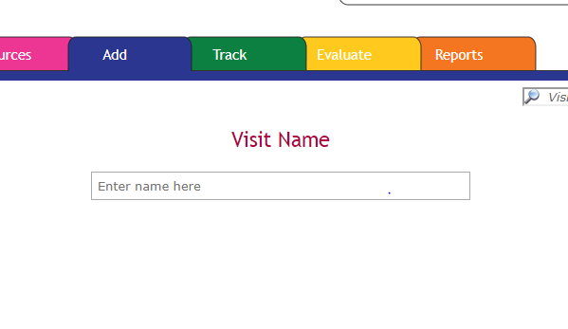
- Select as appropriate.
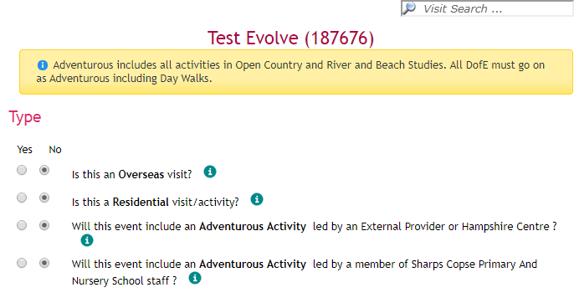

- Tick yes unless it is an evolve for a residential visit
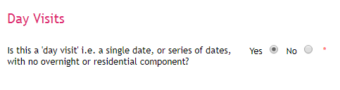
- Please add the purpose of the visit here, you can additional boxes for the intended outcomes.

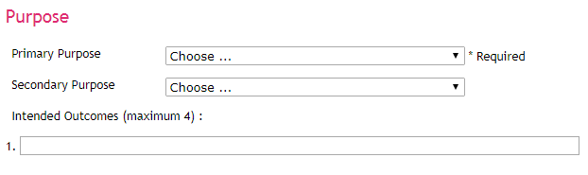
- If the visit is taking place on multiple days i.e. two class visiting separately or a series of visits for example swimming you can select all the dates at this point.


- Enter the times that the visit will take place. If different classes are visiting at different times, then add this in as a note.


- It is unlikely that you would be going on a trip considered to be adventurous.

- If you begin to type in the name of the venue, options will appear in the drop down menu. Alternatively, you can input the details yourself if it is a new venue.
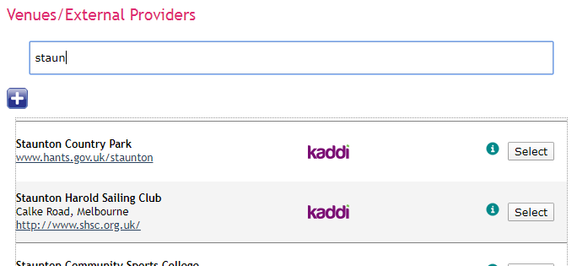

- Please select as appropriate
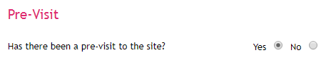

- Please select as appropriate. You can choose more than one mode of transport.
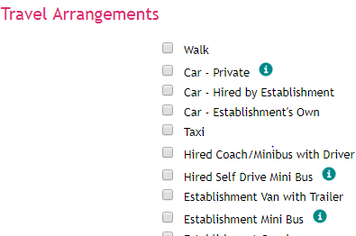

- The trip leader may not be the person completing the evolve form.
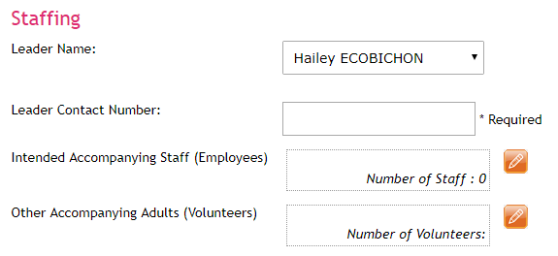
The name of parent helpers can be added to evolve by clicking on the orange pencil and then the blue cross.
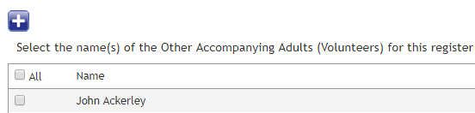

This will appear, allowing you to add the details of new helpers.
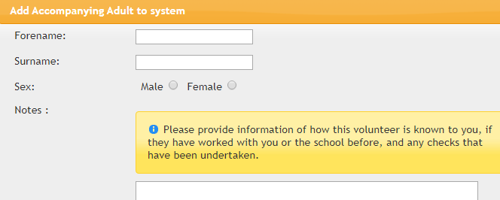

- Please confirm yes
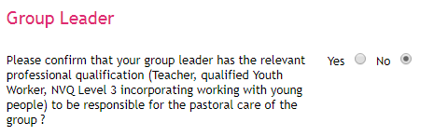

- If staff cover is required a further question will appear asking for clarification of cover arrangements.
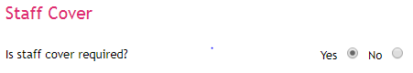

- Please select the key stage of the year group you are taking on the visit.
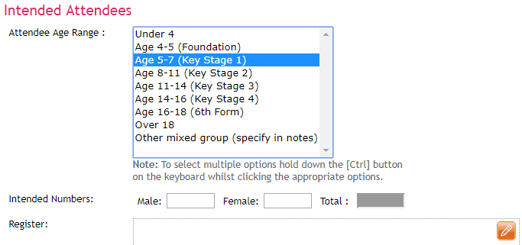
Then click on the orange arrow next to Register box.
Click on the blue cross and a new menu will appear.
You can select the correct attendees by finding your class name under ‘Tutor Groups’ and then search.
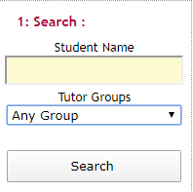

Select the names of children attending and then move to the bottom of the page and click on continue.

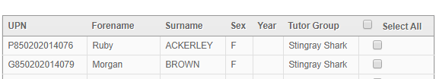

You can now use the group and additional info sections to move children into groups, trip dates, mini bus journeys etc.
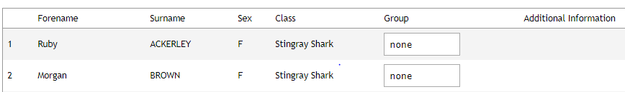

- Complete as required


- Complete as required
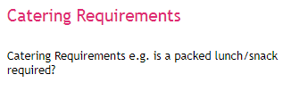
- Please type the name of the class/ classes or group of children attending the visit.
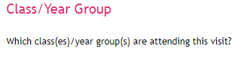

- You are being asked to confirm that you have completed a risk assessment. The evolve form cannot be submitted without one.
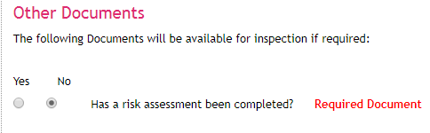

- You need to add two emergency contact numbers. One will need to be the school office and the other a member of the leadership team or admin officer.
Please do NOT use your phone number here.
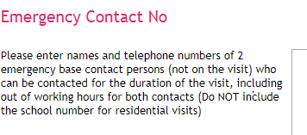
For a residential visit, the contacts will need to be two members of the leadership team or admin officer. Please make sure that they are aware that you are using their number so that they have their phone available to them. The contact numbers you use cannot be attending the visit.

- If a financial contribution is required, please enter the amount. As a payment deadline will already be in place, please add that in the further question.
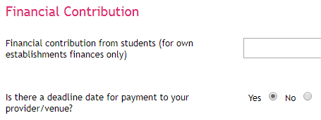

- If you select yes to having children with specific needs
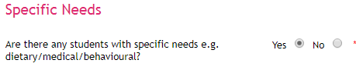
Then a further question will appear asking for more information about the needs.
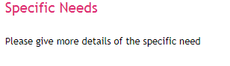
- If you select yes to having a qualified first aider, then you will be asked to confirm their name in an additional question.

- There are several types of documents you could attach by selecting the blue cross.

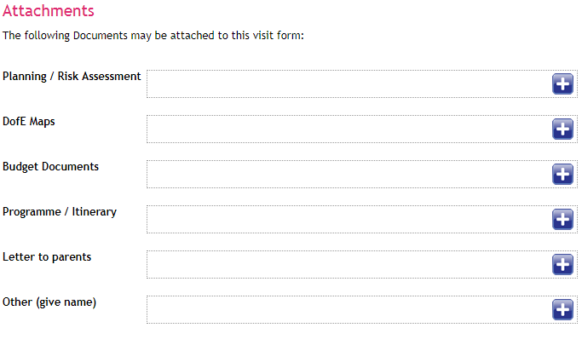
An itinerary is recommended and essential if the visit is residential.
If you have not confirmed travel arrangements in the ‘intended attendees’ section, then you may do this by adding an attachment.
You can confirm groupings through an attachment

- Now submit your evolve form to the EVC

25 If you have any amendments to your form then you can communicate these via a note either before or after the form has been submitted / taken place.

