Sharps Copse Primary School
2024-25

Whole School Attendance Policy

Leigh Park Schools (names to be added)

Policy Consultation & Review

This policy is available on our school website and is available on request from the school office. We also inform parents about this policy when their children join our school and regularly thereafter through our school newsletter and other relevant opportunities.

We recognise the expertise our staff build by managing school attendance daily and we therefore invite staff to contribute to and shape this policy and associated attendance and safeguarding arrangements.

This policy will be reviewed in full by the Governing Body on at least an annual basis. This policy was last reviewed and agreed by the Governing Body on 28th November 2024. It is due for review on 28th November 2025

Signature Headteacher Date:

Signature Governors Date:

Contents

1. Introduction/Aim 4
2. Legal Framework 5
2.1 The Role of the Parent 5
3. Roles and Responsibilities 6
3.1 Promoting strong attendance 9
3.2 Rewards 9
3.3 Absence from school 9
3.4 Safeguarding students who do not attend school 9
3.5 Communication 10
3.6 Absences 10
3.7 Authorised Absence 10
3.8 Unauthorised Absence 10
4. Categorising Absence and Attendance 10
4.1 Leave of Absence 10
4.2 Medical Appointments and absence due to illness 11
4.3 Student Absence for the purposes of Religious Observance 12
4.4 Parent travelling for occupational purposes 12
4.5 Unauthorised Absence 12
5. Our Procedures 13
5.1 Register Keeping and Recording 13
5.2 Late Arrival at School 14
5.3 Persistent Absence, Severe Absence and the use of legal interventions 15
5.4 Support Systems 16
6. Related Policies 17
7. Statutory Framework 17
8. Appendices 18
Appendix 1 – Attendance and Absence Codes 18
Appendix 2 - Authorised Absence 22
Appendix 3 - Unauthorised absence 23
Appendix 4 - Procedures for Safeguarding as follow up to non-attendance 24
Appendix 5 – Attendance Team Actions 25
Appendix 6 - Procedures for unauthorised absences 26
Appendix 7 - “Fixed Penalty Notice” 27
Appendix 8 - Lateness processes 29
Appendix 9 – Request to authorise absence from school due to exceptional circumstances 30
Appendix 10: Attendance Policy Quick Guide for Parents 32

Introduction/Aim

At Sharps Copse Primary we believe that regular school attendance is essential if children are to achieve their full potential. We expect excellent attendance from everyone and recognise that when students are fully engaged in their learning and happy in school, their attendance is likely to be strong. We strive to support all students in achieving 100% attendance and good punctuality.

Missing out on lessons leaves children vulnerable to falling behind and can put them at risk of wider harm. There is a wide range of evidence as to the health and wellbeing benefits of school-age education. Research commissioned by the Department for Education shows missing school for even a day can mean a child is less likely to achieve good grades, which can have a damaging effect on their life chances. As set out in this policy, we will work with families to identify the reasons for poor attendance and try to resolve any difficulties at the earliest opportunity.

It is essential that students attend school every day on time. The development of these routines around attendance and punctuality, not only support strong progress in school but also establish these habits for the future and the world of work.

Why regular attendance is vital

Statistics show a direct link between under-achievement and absence below 95%.
Regular attenders make better progress, both socially and academically.
Regular attenders find school routines, school work and friendships easier to cope with.
Regular attenders find learning more satisfying.
Regular attenders are more successful in transferring between primary school, secondary school and higher education, employment or training.
Learning: - any absence affects the pattern of a child’s schooling and regular absence will seriously affect their learning. Any pupil’s absence disrupts teaching routines so may affect the learning of others in the same class.

Our attendance policy aims to give clear guidance to staff, parents, students, and governors to:

Promote good attendance, enabling students’ achievement by establishing the highest possible levels of attendance and punctuality.
Recognise the key role of all staff in promoting good attendance.
Provide a clear framework for monitoring and responding to student absences, acting early to address patterns of absence.
Building strong relationships with families to ensure students have the support in place to attend school.
Promote positive support systems and advocate multi-agency approaches to improve attendance.
Make parents aware of their legal responsibilities and ensure their children have access to the education to which they are entitled.

We recognise that attendance is a matter for the whole school community. Our Attendance Policy should not be viewed in isolation; it is a strand that runs through all aspects of school improvement, supported by our policies on safeguarding, prevention of bullying, behaviour, and inclusive learning. This policy also considers the Human Rights Act 1998, the Equality Act 2010, UN Convention on the Rights of the Child, and other relevant legislation.

Legal Framework

This policy meets the requirements of the Working together to improve school attendance from the Department for Education (DfE), and refers to the DfE’s statutory guidance on school attendance parental responsibility measures.

Section 7 of the 1996 Education Act states that parents must ensure that children of compulsory school age receive efficient full-time education suitable to their age, ability, and aptitude to any special educational needs they may have, either by regular attendance at school or otherwise. A child is of compulsory school age at the beginning of the term following their 5th birthday. A child ceases to be of compulsory school age on the last Friday in June of the school year in which they reach the age of 16.

The government expects all schools and local authorities to:

Promote good attendance and reduce absence, including persistent and severe absence.
Ensure every student has access to full-time education to which they are entitled.
Act early to address patterns of absence.

Parents are expected to perform their legal duty by ensuring their children of compulsory school age who are registered at school attend regularly.

In accordance with the Education Act 1996, we will work with parents and carers and the Local Authority to ensure that parents and carers are supported to secure education for children of compulsory school age. Where required, we will formalise support and where necessary, work with the LA to use legal measures.

A “Parent” is defined as:

Any natural parent, whether married or not.
Any parent who, although not a natural parent, has parental responsibility as defined in the Children Act (1989) for a child or young person.
Any person who, although not a natural parent, has care of a child or young person.

2.1 The Role of the Parent
Whatever efforts are made by the school staff, it is ultimately parents’ responsibility to see that their child attends school regularly and punctually. If parental support is not forthcoming, strategies to encourage good attendance may fail.

Parents are expected to:
- Ensure their child attends every day the school is open except when a statutory reason applies.
- Notify the school as soon as possible when their child has to be unexpectedly absent, e.g. sickness.
- Only request leave of absence in exceptional circumstances and do so in advance.
- Book any medical appointments around the school day where possible
- If there are attendance concerns, proactively engage with support offered to prevent the need for more formal support.

In case of absence, parents should:

- Contact the school before 8.30am on the first day of absence, giving a reason and approximate anticipated length of absence.
- On the student’s return to school, parents must provide written evidence of the reason for absence (further clarification may be sought by the school)
- Make every effort to ensure medical/dental appointments are made out of school hours. If this is unavoidable, the school should be informed in advance. The school reserves the right to mark as unauthorised any time taken for medical/dental appointments when the student is not accompanied on return to school by an appointment slip.

Roles and Responsibilities

At Sharps Copse Primary, we believe that improving school attendance is everyone’s business. It is a shared responsibility by governors, all school staff, parents, students, the wider school community and multi-agency partners. We aim to always work in partnership with our parents.

Role | Name | Contact details
Senior Attendance Lead/Champion | Mike Elsen
Attendance Officers | Vickie Richardson and Linda Cutting
Attendance assistant | Kate Burn
Named Governor for Attendance | To be advised

The Governors of Sharps Copse Primary recognise the importance of school attendance and promote it through the school’s ethos and across its policies. They take an active role in attendance improvement by:

Setting high expectations of all leaders, staff, students, and parents so that children attend school every day and are safeguarded.
Identifying a member of the governing body to lead on attendance matters and ensuring that there is a named senior manager to lead on attendance.
Prioritising attendance in strategies, such as raising attainment, behaviour and combatting bullying, special educational needs and disabilities, wellbeing, and safeguarding.
Ensuring school leaders fulfil expectations and statutory duties by rigorously evaluating the effectiveness of the school’s attendance procedures so that consistent attendance support is provided for all students.
Ensuring the schools’ attendance management processes are delivered effectively, and that consistent attendance support is provided for students who require it most by prioritising the staff and resources needed. This includes ensuring schools engage and work effectively with the local authority School Attendance Support Team and wider local partners and services.
Regularly reviewing attendance data, discussing, challenging trends, and helping school leaders focus improvement efforts on the individual students or cohorts who need it most.
Ensuring high aspirations are maintained for all students and processes for support are adapted to the individual needs of students including those with long term illnesses, special educational needs and disabilities, students with a social worker, those students under the Virtual School and students from cohorts with historically lower attendance such as those eligible for free school meals.
Ensuring all school staff receive adequate training on attendance and that relevant staff have access to opportunities to share and learn from good practice in other schools.
Ensuring that attendance data is shared with the Local Authority or Department for Education in line with statutory reporting deadlines.
Reviewing the school’s Attendance Policy on at least an annual basis, ensuring that the required resources are available to fully implement the policy, which is published and publicised regularly so that it is easily accessible to students, parents and staff.

The Senior Leadership Team at Sharps Copse Primary will:

Actively promote the importance and value of good attendance to students and their parents.
Form and maintain positive relationships with students and parents.
Ensure that there is a whole school approach which reinforces good school attendance, with good teaching and learning experiences, with a whole school culture that encourages all students to attend and to achieve.
Make sure all teaching and non-teaching staff know the importance of good attendance, are consistent in their communication with students and parents, and receive the training and professional development they need.
Have a clear school attendance policy which all staff, students and parents understand. Monitor the implementation and effectiveness of the Attendance Policy and ensure that the policy is reviewed annually.
Ensure the school has accurate, complete admission and attendance registers and have effective day to day processes in place to follow-up absence.
Regularly monitor and analyse attendance and absence data to identify students or cohorts that require support with their attendance and put effective strategies in place.
Share information and work collaboratively with other schools in the area, local authorities, and other partners where a student’s absence is at risk of becoming persistent or severe.
Ensure that there is a named Senior Attendance Champion to lead on attendance and allocate sufficient time and resource.
Attend the termly school attendance supporting meetings with the local authority, focusing on those students with severe absence, making sure a regularly reviewed plan is in place.

All staff at Sharps Copse Primary will:

Actively promote the importance and value of good attendance to students and their parents.
Form positive relationships with students and parents.
Contribute to a whole school approach which reinforces good school attendance; with good teaching and learning experiences that encourage all students to attend and to achieve.
Know the importance of good attendance, are consistent in their communication with students and parents, and receive the training and professional development they need.

Sharps Copse Primary expects that parents:

Take a positive interest in their child’s attendance and educational progress.
Ensure their child has regular attendance at school.
Instill the value of education and regular school attendance within the home environment.
Contact the school if their child is absent to let them know the reason why and the expected date of return, following this with a note wherever possible.
Avoid unnecessary absences; for example, by making medical and dental appointments for outside of school hours.
Ask the school for help if their child is experiencing difficulties with any aspect of their schoolwork or home and family life.
Inform the school of any change in circumstances that may impact on their child’s attendance.
Support the school by becoming involved in their child’s education, forming a positive relationship with school, and acknowledging the importance of children receiving the same messages from both school and home.
Maintain effective routines at home to support good attendance.
Attend all meetings requested to discuss attendance issues.
Work with school to support their child if they are struggling with attendance.

Further information can be found at: Attendance guidance for parents | Hampshire County Council (hants.gov.uk)

Pupils will:

Be aware of the school’s attendance policy and when and where they are required to attend. This will be communicated to them by school staff, parents and through the school timetable.
Speak to their class teacher or another member of staff if they are experiencing difficulties at school or at home which may impact on their attendance.
Attend all lessons ready to learn, with the appropriate learning tools requested and on time for the class.
Bring a note of explanation from their parents or guardians to explain an absence that has happened or is foreseen.
Follow the school procedure if they arrive late. This will help the school to monitor attendance and keep accurate records for the child’s individual attendance. This is also vital for health and safety in the event of a school evacuation.

3.1 Promoting strong attendance
Attendance is given a high profile in school and its links to learning and achievement are reinforced through:
- Daily ‘attendance streak’ monitoring
- Weekly tutoring focus
- Assemblies
- Displays in corridors
- Daily absence texts sent for all absentees, followed by home visits if necessary.
- A dedicated attendance team, including home liaison and attendance liaison officers.
- Good attendance of individuals is publicly celebrated half termly

3.2 Rewards
Rewards may include
- Certificates for improved attendance
- Termly attendance rewards for 98-100% attendance
- 100% attendance and punctuality = Termly certificate awarded
- Rewards for tutor group highest attendance
- Rewards for attendance streaks at 15 and 25 days

3.3 Absence from school
When a student is absent without explanation school will endeavour to contact the parent as soon as possible. Notes, records of telephone calls and medical certificates/evidence will be kept on file and referred to as and when appropriate, e.g. If legal action is required.

School will closely monitor the attendance of all students. School leaders and the Attendance Team work closely together to identify children at risk of becoming persistent absentees (PAs) i.e. below 90% attendance and will offer support to parents as appropriate.

3.4 Safeguarding students who do not attend school
- On the first day of absence, a text will be sent. If no response it will be followed up by a phone call made to the parent. This will be repeated for all subsequent days of absence.
- If no contact is made with home and there is a second day of absence immediately after the first, the above process will be repeated.
- If school are unable to contact home on the third day, having made enquiries with other family members, then a home visit will take place.
- If school are unable to contact home on the third day, having made further enquiries, including to other family members, the school will begin ‘child missing in education’ procedures as set down by Hampshire County Council Guidance.
- If a child is absent for 20 consecutive days, we are required to notify the Local Authority that the child is ‘Pupil Missing Out On Education (PMOOE).’
(see Appendix 4)

3.5 Communication
- On the first day of absence, school expects parents to inform them of the absence and the reasons for it.
- If we do not receive notification, we will text to check the reason for the absence after 9.20 am.
- Reasons for absence are recorded on Arbor.

3.6 Absences
If a pupil of compulsory school age is absent, the am and pm register must show whether this was authorised or unauthorised.

- Authorised absence is where the school has either given approval in advance for a student to be away or has accepted an explanation offered afterwards as satisfactory justification for absence (see Appendix 2).

3.7 Authorised Absence
- The Department for Education (DFE) makes clear that it is only the school that can authorise an absence, not parents.
- If a parent’s note offers an unacceptable explanation for an absence, then the school will not authorise it.

3.8 Unauthorised Absence
- If we feel a child has had too many authorised absences, usually 10 sessions, future absences will not be authorised unless there is clear evidence that the absences were unavoidable (see Appendix 3 for examples of circumstances that would be considered unauthorised absence.)
- ALL OTHER ABSENCES MUST BE TREATED AS UNAUTHORISED

Categorising Absence and Attendance

When marking our registers, we will apply the national codes as outlined and regulated by the Department for Education guidance to accurately record and report attendance.

4.1 Leave of Absence
Since September 2013, changes to Government regulations and guidance mean that Headteachers can no longer authorise leave of absence unless there are exceptional circumstances. Generally, the DfE does not consider a need or desire for a holiday or other absence for the purpose of leisure and recreation to be an exceptional circumstance. Leave of absence should not be granted for a student to take part in protest activity during school hours. All absences associated with a holiday or other absence for the purpose of leisure and recreation during term time will be marked as unauthorised within the register. Any parents known to have removed their child from school for the sole purpose of a holiday or other absence for the purpose of leisure and recreation may be referred to the Local Authority and be issued with a penalty notice fine or referred to the Local Authority to consider prosecution.

We believe that children need to be in school for all sessions so that they can make the most progress possible. However, we do understand that there are times where a parent may legitimately request leave of absence for a child due to ‘exceptional circumstances'. At Sharps Copse Primary, leave of absence is only granted at the discretion of the Headteacher and shall not be granted unless there are ‘exceptional circumstances’. Sharps Copse Primary School will respond to all applications for leave of absence in writing.

Parents wishing to apply for leave of absence during term time must apply in writing to the Headteacher at least a month before the planned leave (see Appendix 2). If a written request for leave of absence is not completed and the leave is taken without a request being submitted, the leave will not be considered by the Headteacher, and it will be marked as unauthorised. Sharps Copse Primary will treat each application individually and discuss with you the circumstances of the application before a decision is made. Retrospective requests will not be considered and therefore will result in the absence being categorised as unauthorised.

A penalty notice request or a referral for prosecution may be submitted to the Local Authority should:

The parent fail to submit a leave of absence request in advance of taking the leave.
An application for a leave of absence is not agreed by the Headteacher but is still taken.
A longer period is taken more than the agreed number of days.

When absence is granted by the Headteacher, the parents will need to agree a date of return. If a student fails to return on the expected date and contact is not received from, or made with the parents, school will seek advice from the Local Authority. This could result in possible children missing from education procedures being instigated.

The 1996 Education Act also sets out the circumstances in which a student has not failed to attend school regularly and therefore the parent has not committed an offence. 4.2, 4.3, 4.4 are examples of these. The full list is in the Appendix 6.

4.2 Medical Appointments and absence due to illness
Parents should try to make appointments outside of school hours wherever possible. Where appointments during school time are unavoidable, we ask that parent notifies the school in advance of the appointment wherever possible. The student should only be out of school for the minimum amount of time necessary for the appointment. In most circumstances, a child should not miss a whole day at school for an appointment. If a student must attend a medical appointment during the school day, they must exit via reception, reporting to reception staff as they leave. No student will be allowed to leave the school site without parental confirmation.

In line with Department for Education guidance, if we do have a genuine concern about the authenticity of the illness, we may ask the parent to provide medical evidence, such as a prescription, appointment card, or other appropriate form of evidence. If the school is not satisfied about the authenticity of the illness, the absence will be recorded as unauthorised.

Where a child has an emerging a pattern of non-attendance, we will discuss the reasons for absence with the child’s parent. We will invite parents to attend a support meeting as an appropriate early intervention strategy. As part of this support, we may seek consent from parents and the student as appropriate to make a referral to the School Nursing Team and/or to liaise with the child’s healthcare professional.

Where a student has a verified and chronic health condition, we will aim to work with parents to ensure children have access to education and provide appropriate support in line with Supporting students with medical conditions at school and Hampshire policies regarding supporting children with health issues, Behaviour and attendance resources for schools | Hampshire County Council (hants.gov.uk). We will also consider whether an Individual Healthcare Plan is required.

4.3 Student Absence for the purposes of Religious Observance
Sharps Copse Primary acknowledges the multi-faith nature of British society and recognises that, on some occasions, religious festivals may fall outside school holiday periods or weekends and is recognised as such by a relevant religious authority. Where this occurs, the school will consider either authorising the student absence or making special leave for religious observance. Parents are requested to give advance notice to the school.
Working together to improve school attendance - GOV.UK (www.gov.uk) page 86

4.4 Parent travelling for occupational purposes
The student is a mobile child and their parent(s) is travelling in the course of their trade or business and the student is travelling with them. A mobile child is a child of compulsory school age who has no fixed abode and whose parent(s) is engaged in a trade or business of such a nature as to require them to travel from place to place.

To ensure we can effectively support all our students, we ask that parents:

Advise the school of their forthcoming travelling patterns as soon as these are known and before they happen; and
Inform the school regarding proposed return dates.

4.5 Unauthorised Absence
Absence will not be authorised unless parents have provided a satisfactory explanation and it is accepted as such by the school. The decision to authorise absences is at the discretion of the Headteacher. Examples of unsatisfactory explanations include but are not limited to:

A student’s/family member’s birthday.
Shopping for uniforms.
Arrangements or appointments for cutting the student’s hair.
Closure of a sibling’s school for INSET (or other) purposes.
An unwillingness to attend school, or inability to attend owing to inadequate personal/family organisation.
A refusal to attend school on health grounds but where the student is considered well enough to attend.
Absences taken without the authorisation of the school.

Our Procedures

5.1 Register Keeping and Recording
The Education (Pupil Registration) (England) Regulations 2006, as amended by 2016 regulations, require schools to take an attendance register twice a day, once at the start of the morning session and then again during the afternoon session.

For the purpose of this policy, the school defines:

“Absence” as:
Arrival at school after the register has closed.
Not attending school for any reason.

“Regular” attendance as:
Attendance at every session the school is open to students unless their absence has been authorised.

Completing the register
Registers are legal documents that are used as evidence where parents are being prosecuted for attendance offences. They are retained by the school even after a student has left school.

The governing body is legally responsible for ensuring the school maintains accurate admission and attendance registers.

Registers at Sharps Copse Primary School are completed using the Arbor system in the main school office (Class teachers record the attendance on registers and send these down to the main office).

In the register students will be entered under their legal name on their birth certificate or as changed by deed poll; their known name may be shown on the register in brackets.

Registration
The register is a legal document. It is the responsibility of each teacher to ensure that information is accurately entered onto the register as follows:

- AM and PM registers must be completed.
- All students should be registered in every lesson unless there is a clear reason not to do so.
- Registers must be completed using agreed symbols for class registers and uploaded onto Arbor.
- Teachers are responsible for taking the register, not students.

The member of staff responsible for attendance will work to further develop relationships with families to bring about improved attendance. This may involve seeking multi-agency support.

Students must arrive in school by 8:50 am on each school day.

The register for the first session will be taken at 8:55am and will be kept open until 9:20am. The register for the second session will be taken on completion of lunch and the return to class by the pupils. (Lunch is staggered so timings not included). 1:30 pm is the latest for registers to be returned to the office.

Registers are legal records and all schools must preserve every entry in the attendance or admission register for 6 years from the date the data was entered. As the attendance register is a record of the students present at the time it was taken, the register should only routinely be amended where the reason for absence cannot be established at the time it is taken and it is subsequently necessary to correct the entry. Where amendments are made, all schools must ensure the register shows the original entry, the amended entry, the reason for the amendment, the date on which the amendment was made, and the name of the person who made the amendment.

On each occasion the register is taken the appropriate national attendance and absence code must be entered for every student (of both compulsory and non-compulsory school age) whose name is listed in the admission register at the time. The codes enable schools to record and monitor attendance and absence in a consistent way and are used to collect statistics. The data helps schools, local authorities, and the government gain a greater understanding of the delivery of education and the level of, and reason for, absence.

Reporting to parents
The school will include attendance in parents’ evenings (where there is a concern) and in the school reports which go home to parents in the summer annual report.

5.2 Late Arrival at School
- Pupils arriving after the am register has been taken must be marked with a 0 by class teacher and adjusted by the office.
- HT, HSLW, Admin manager and Admin assistant will discuss pupils with persistent poor punctuality and take appropriate action.

Students who arrive after 9:00 am will need to enter school via main reception to sign in (see Appendix 8).

Monitor and Analyse attendance

Sharps Copse Primary will:

Monitor and analyse weekly attendance patterns and trends and deliver intervention and support in a targeted way to pupils and families. This should go beyond headline attendance percentages and should look at individual pupils, cohorts and year groups (including their punctuality) across the school.
Use this analysis to provide regular attendance reports to class teachers to facilitate discussions (including any special educational needs coordinators, designated safeguarding leads).
Undertake frequent individual level analysis to identify the pupils who need support and focus staff efforts on developing targeted actions for those cases.
Conduct thorough analysis of half-termly, termly, and full year data to identify patterns and trends. This should include analysis of pupils and cohorts and identifying patterns in uses of certain codes, days of poor attendance and where appropriate,
Benchmark attendance data (at whole school, year group and cohort level) against local, regional, and national levels to identify areas of focus for improvement.
Devise specific strategies to address areas of poor attendance identified through data.
Monitor in the data the impact of school wide attendance efforts, including any specific strategies implemented. The findings should then be used to evaluate approaches or inform future strategies.
Provide data and reports to support the work of the board or governing body and local authority when appropriate.

At Sharps Copse Primary School we will investigate any pupils who are on track to be persistently absent (PA) and will not wait until attendance is below 90%.

“Persistent absenteeism” (PA) as:
Missing 10% or more of schooling across the year for any reason.

“Severe absence” (SA) as:
Missing 50% or more of schooling across the year for any reason.

5.3 Persistent Absence, Severe Absence and the use of legal interventions
A pupil becomes a ‘persistent absentee’ (PA) when their attendance drops to 90% and below for any reason. Over a full academic year this would be 38 sessions (19 days). Absence at this level could cause considerable damage to a child’s educational outcomes.

A pupil becomes a ‘severe absentee’ (SA) when their attendance drops to 50% and below for any reason. Over a full academic year this would be 190 sessions (95 days). Absence at this level is causing considerable damage to a child’s educational outcomes.

The attendance of all pupils at our school are monitored to identify children who are PA, or are on track to becoming PA. Where emerging concerns are identified we will instigate appropriate and timely interventions as outlined in the section above. Referrals may also be made to external agencies for targeted support. Inclusion Support Service (ISS) | Hampshire County Council (hants.gov.uk)

If parents fail to engage with support and their child continues to have unsatisfactory attendance/ punctuality, a request may be made to the Local Authority to pursue legal proceedings either through a penalty notice, consideration of an Education Supervision Order or prosecution via the Magistrates’ Court.

Parents found guilty of failing to secure their child’s regular attendance at school under the provisions of the Education Act 1996, will receive a criminal record and a maximum penalty of a £1000 fine under a Section 444 (1) offence or a £2500 fine or up to a 3-month prison sentence, under a Section 444 (1a) offence.

In line with Hampshire County Council guidance, we will notify the Inclusion Support Service of all reduced timetables as soon as a plan has been agreed.

Addressing Poor attendance
- After 5 sessions of unauthorised absence, in a 50-session period, the Attendance Officer will send a warning letter.
- After 10 sessions of unauthorised absence a fixed term penalty may be issued.
- The Home School Link Worker or Admin Officer will liaise with local GP’s if poor attendance seems to be linked to medical problems.
- The school may also make a referral to the Legal Intervention Team (LIT) where there are concerns re poor attendance which does not improve after the issue of fixed term penalty and school intervention (see Appendix 5).

5.4 Support Systems
At Sharps Copse Primary we recognise that poor attendance can be an indication of difficulties in a family’s life. This may be related to problems at home and or in school. Parents are encouraged to inform school of any difficulties or changes in circumstances that may affect their child’s attendance and/or behaviour in school, for example: bereavement, divorce/separation, emerging health concerns. This will help the school identify any additional support that may be required.

We also recognise that some students are more likely to require additional support to attain good attendance. The school will implement a range of strategies to support improved attendance based on the individual needs and circumstances of the child.

Strategies for maintaining and Improving attendance may include:
- Rewards to promote strong attendance and attendance streaks (uninterrupted days of attendance)
- Flexible start time adapted at the start and end of the school day to welcome pupils, support them with their day encourage attendance
- Parent and pupil awareness as to the importance of good attendance – regular information given in: assemblies, newsletters, displays, rewards, Parents’ evenings.
- Key members of staff responsible for providing attendance data and monitoring consistency of records across the whole school. (Attendance team)
- Concerns regarding attendance go through fortnightly referral meetings.
- Prompt follow-up on absence – 1st day contact made with home via text and followed up by calls or visits where necessary.
- Attendance Team to have identified strategies for helping students return from absence and, in addition, year teams offer supportive advice to returning pupils
- Use of Educational Psychologist, SENDCO in setting up suitable re-integration programmes for poor attendees.
- Individual Attendance Action plans (IAP’s) created for poor attenders in conjunction with parent and student.

To plan the correct support, we will always invite parents and pupils to attend a meeting to discuss the concerns and devise a plan to support the child’s regular attendance. Support offered to families will be child-centred and planned in discussion and agreement with both parents and students.

Attendance Team:
- Will meet with and offer support to parents whose children have attendance/ punctuality issues.
- Create Individual Attendance Plans to support the improvement of attendance
- Work with students and families who require ongoing support to remove barriers affecting attendance

Related Policies

To underpin the values and ethos of our school and our intent to ensure that students at our school attend school regularly and reach their full potential, the following policies are integral to this approach:

Safeguarding including child protection
Medical needs
Admissions
Anti-bullying
Exclusion
Special educational needs
Teaching and learning
Behaviour and rewards.

Statutory Framework

This policy has been devised in accordance with the following legislation and guidance:

- Working together to improve school attendance, DfE, (August 2024)
- School attendance parental responsibility measures, DfE (January 2015)
- Children missing education, DfE (September 2016)
- Keeping children safe in education, DfE (September 2024)
- Working together to safeguard children, DfE (July 2023)

Appendices

Appendix 1 – Attendance and Absence Codes

Code |  |  |  | Definition | Scenario
/ |  |  |  | Present (am) | pupil is present at morning registration
\ |  |  |  | Present (pm) | pupil is present at afternoon registration
L |  |  |  | Late arrival | pupil arrives late before register has closed
B |  |  |  | Off-site educational activity approved by the school.  Schools must also record the nature of the approved educational activity. | Examples of nature of activity  - 1) Attending taster days at college  - 2) Attending courses at college  - 3) Attending unregistered alternative provision arranged by the school
D |  |  |  | Dual registered | pupil is attending a session at another setting where they are also registered
K |  |  |  | Attending education provision arranged by the Local Authority  Schools must also record the nature of the provision | • Attending courses at college  • Attending unregistered alternative provision such as, home tutoring
P |  |  |  | Sporting activity | The pupil is attending a place for an approved educational activity that is a sporting activity
V |  |  |  | Educational visit or trip | An educational visit or trip arranged by or on behalf of the school and supervised by a member of school staff
W |  |  |  | Attending work experience | The pupil is attending a place for an approved educational activity that is work experience provided under arrangements made by a local authority or the school as part of the student’s education
Code |  |  |  | Definition | Scenario
Absent – leave of absence
C |  | Leave of absence for exceptional circumstances  Generally, a need or desire for a holiday or other absence for the purpose of leisure and recreation would not constitute an exceptional circumstance |  |  | Schools must judge each application individually considering the specific facts and circumstances and relevant background context behind each request. Where a leave of absence is granted, the school will determine the number of days a student can be absent from school
C1 |  | Leave of absence for the purpose of participating in a regulated performance or undertaking regulated employment abroad |  |  | All schools can grant leaves of absence for students to undertake employment (paid or unpaid) during school hours
C2 |  | Leave of absence for a compulsory school age student subject to a part-time timetable |  |  | All pupils of compulsory school age are entitled to a full-time education. In very exceptional circumstances, where it is in a student’s best interests, there may be a need for a temporary part-time timetable to meet their individual needs
E |  | Excluded |  |  | Suspended or permanently excluded and no alternative provision made
I |  | Illness (not medical or dental appointment) |  |  | The student is unable to attend due to illness (both physical and mental health related). Schools should advise parents to notify them on the first day the child is unable to attend due to illness
J1 |  | Interview |  |  | Attending an interview for employment or for admission to another educational institution
M |  | Medical appointment |  |  | Attending a medical or dental appointment
R |  | Religious observance |  |  | The pupil is absent on a day that is exclusively set apart for religious observance by the religious body the parent(s) belong to
S |  | Study leave |  |  | Studying for a public examination. Must be used sparingly with revision opportunities in school
T |  | Parent travelling for occupational purposes |  |  | The pupil is a mobile child and their parent(s) is travelling in the course of their trade or business and the pupil is travelling with them
X |  | Non-compulsory school age pupil not required to attend school
Code |  | Definition |  |  | Scenario
Absent - unable to attend school because of unavoidable cause
Q |  |  | Unable to attend the school because of a lack of access arrangements |  | This is linked to transport not other access arrangements
Y1 |  |  | Unable to attend due to transport normally provided not being available |  | The school is not within walking distance of the pupil’s home and the transport to and from the school that is normally provided for the student by the school or local authority is not available
Y2 |  |  | Unable to attend due to widespread disruption to travel
Y3 |  |  | Unable to attend due to part of the school premises being closed
Y4 |  |  | Unable to attend due to the whole school site being unexpectedly closed |  | Adverse weather
Y5 |  |  | Unable to attend as student is in criminal justice detention |  | In police detention, remanded to youth detention, awaiting trial or sentencing, or detained under a sentence of detention.
Y6 |  |  | Unable to attend in accordance with public health guidance or law
Y7 |  |  | Unable to attend because of any other unavoidable cause |  | An emergency has prevented the student from attending. The unavoidable cause must be something that affects the student, not just the parent.
Code |  |  | Definition |  | Scenario
Unauthorised absence
G | Unauthorised holiday |  |  |  | Holiday not granted by the school
N | Reason for absence not yet established |  |  |  | pupil is absent for an unknown reason (this code should be amended when the reason emerges, or replaced with code O if no reason for absence has been provided after a reasonable amount of time)
O | Absent in other or unknown circumstances |  |  |  | Where no reason for absence is established or the school is not satisfied that the reason given
U | Arrival after registration |  |  |  | A pupil has arrived late after the register has closed but before the end of session.
Code | Definition |  |  |  | Scenario
Administrative Codes
Z |  | Prospective student not on admission register |  |  | To enable schools to set up registers in advance of students joining the school to ease administration burdens.
# |  | Planned whole school closure |  |  | Whole school closure due to half-term/bank holiday/INSET day/use of whole school as polling station

Appendix 2 - Authorised Absence

An absence may be counted as authorised if a child is absent:

• When prevented from attending by illness.
• On a day set aside for religious observance.
• Participating in a public performance.

Furthermore, the school may “reasonably exercise discretion to grant leave” for:

• Absence following the death of a close family member of the child’s family.

Appendix 3 - Unauthorised absence

Circumstances that may lead to parentally condoned absences but would not be authorised include:

• The child’s father/mother/carer being ill
• A student being used to support members of the family
• Family work patterns
• A parent’s desire for company
• Family holiday
• Indulging a child who wants to stay at home
• A child’s birthday
• Apathy on the part of the parent
• Buying clothes
• A parent’s inability to control the child
• Child used as an interpreter
• Uneasy relationships with an institution representing authority

Appendix 4 - Procedures for Safeguarding as follow up to non-attendance

Appendix 5 – Attendance Team Actions

Personalised follow up of non-attendance of identified vulnerable students
Contact parents on behalf of tutor to attend tutor meeting

Attendance Team Actions when students are at or below 96%
- Vulnerable students identified for Year Leaders
- Warning Letter sent if student reaches absenteeism of 6/50 sessions.

Individual Attendance Planning (IAP) meeting led by Attendance Officer or Year Leader
- Warning Letter sent if student reaches absenteeism of 9/50 sessions, with invitation to IAP meeting
- Discuss barriers, agree targets and actions.
- Potential interventions and support are selected as appropriate from menu below

Attendance Team Actions when students are at or below 92%
- The Home School Link Worker and another attendance team member makes initial home visit assessment with hard to reach parents.
- Fixed Penalty Notice issued or Legal Intervention Team (LIT) at absenteeism of 10/100 sessions.

Internal Actions
- Home Visits
- SEN support
- Multi-agency meeting
- Daily Home Visits
- Legal Intervention Team (LIT)
- Time Out card
- Referral Process
- Include Team in-school support
- Attendance Report
- Specialist Group Work
- Personalised Programmes
- Include

Outside Agencies
- Educational Psychologist
- CP Referral
- Social Care
- Legal Intervention Team (LIT)
- Parent Partnership
- Locality Team Family Support Worker
- YCP
- Motiv8
- YOT
- CAMHS
- Medical officer
- Outreach Worker
- Early Help Hub (EHH)
- Mental Health Support Team (MHST)

Appendix 6 - Procedures for unauthorised absences

Any absences which are not covered by the definition of authorised absence or after 10 previous sessions of authorised absence, will be regarded as unauthorised.

Student is a persistent absentee and serious cause for concern
Student in danger of becoming a persistent absentee.
Attendance is a cause for concern


Appendix 7 - “Fixed Penalty Notice”

Penalty Notices
(To address poor attendance and punctuality at school)
The Education Act 1996, section 444A

Advice to parents and carers from the Children’s Services Department

• Penalty Notices and the Education Act 1996
Section 444A of the Act gives powers to the Local Authority (LA) and other designated bodies (including headteachers) to issue Penalty Notices where a parent/carer is considered capable of but unwilling to secure an improvement in their child’s school attendance and/or punctuality. The person authorised to issue Fixed Penalty Notices for Sharps Copse Primary is Michael Elsen, Headteacher.

• Why use them?
Reducing absence and improving punctuality in schools is a key priority both nationally and locally because missing school damages a pupil’s attainment levels, disrupts school routines as well as the learning of others and can leave a pupil vulnerable to anti-social behaviour and youth crime.

Above all, missing school seriously affects children’s longer-term life opportunities.

Under existing legislation, parents/carers commit an offence if their child fails to attend school regularly and punctually and the absence is recorded by the school as unauthorised. Absence is recorded as unauthorised unless it is taken with the permission of the school or is for some unavoidable reason. Punctuality is recorded as unauthorised absence when the pupil arrives after the register has been closed.

Depending upon the circumstances, such cases may result in prosecution by the LA under the Education Act 1996, section 444. A Penalty Notice is an alternative to prosecution.

• What is a Penalty Notice?
A Penalty Notice is a fine which may be issued as an alternative to prosecution. It does not require a court appearance and does not result in a criminal record. Payment of a Penalty Notice enables the parent/carer to discharge the potential liability for prosecution and subsequent conviction.

• What is the cost of a Penalty Notice?
Payment of a Penalty Notice is:
Fixed Penalty notice 1 = £160 to be paid in 28 days, reduced to £80 if paid in 21 days.
Fixed penalty notice 2 = charged at a flat rate of £160 if paid in 28 days

• How is a Penalty Notice issued?
By post to your home

• When are they issued?
Hampshire County Council and Hampshire schools consider that regular attendance and punctuality is of such importance that Penalty Notices may be issued where a pupil has had 10 or more half-day sessions i.e. the equivalent to 5 school days of unauthorised absence, in any 10 school week period and
- where issuing a Penalty Notice will be an effective measure in helping the pupil return to school and/or ensure their future regular attendance/punctuality
- where the parent/carer is capable of ensuring the pupil’s regular attendance/punctuality
- where the parent/carer has failed to cooperate in making use of advice/support offered.
- Where parents are deliberately avoiding the national threshold by taking several term time holidays below threshold, or for repeated absence for birthdays or other family events
NB. A Penalty Notice may also be issued where a parent/carer takes a child on holiday during term-time.

• Is a warning given?
In most situations the parent/carer will be given a written warning of the possibility of a Penalty Notice being issued. This written warning will advise the parent/carer about the extent of the child’s absence and warn them that if the child’s attendance and punctuality does not show a significant improvement and if this improvement is not maintained thereafter, a Penalty Notice may be issued without further warning.

NB. The school may, however, have already warned parents of its policy in respect of term-time holidays. In such cases, if a holiday is taken without the school’s permission beforehand, a Penalty Notice may be issued without a further warning.

• Is there an appeal process?
There is no statutory right of appeal. Once a Penalty Notice has been issued, it can only be withdrawn if it can be shown that it was issued in error.

• How do I pay?
Details of payment arrangements will be included in the Penalty Notice. Payment in part or by instalments of a Penalty Notice is not acceptable.

• What happens if I do not pay?
You will have up to 28 days from receipt to pay the Penalty Notice in full. If you fail to do so, the Local Authority is required, by law, to commence proceedings in the Magistrates’ Court for the original offence of poor school attendance and/or punctuality.

If convicted of this offence under the Education Act 1996, there are a number of possible sentences including a fine of up to £1000 (in the case of a prosecution under section 444(1)) or a fine of up to £2500 and/or a period of up to 3 months’ imprisonment (in the case of a prosecution under section 444(1A)).

• What if my child has further unauthorised absence from school?
If you pay the Penalty Notice and your child has further unauthorised absences, you may be prosecuted for the further unauthorised absences but not for the absences during the period covered by the Penalty Notice.

• Can I get help if my child is not attending school?
Yes. Both the school and Hampshire County Council Children’s Services Department are available to provide advice and support.
Appendix 8 - Lateness processes- VR/LC to design

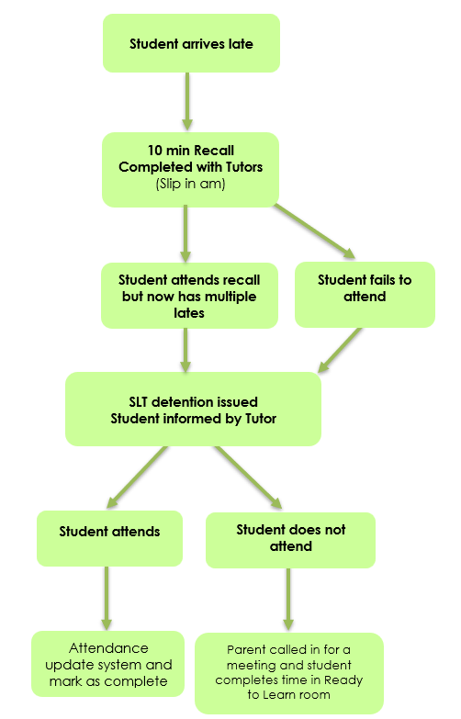

Appendix 9 – Request to authorise absence from school due to exceptional circumstances
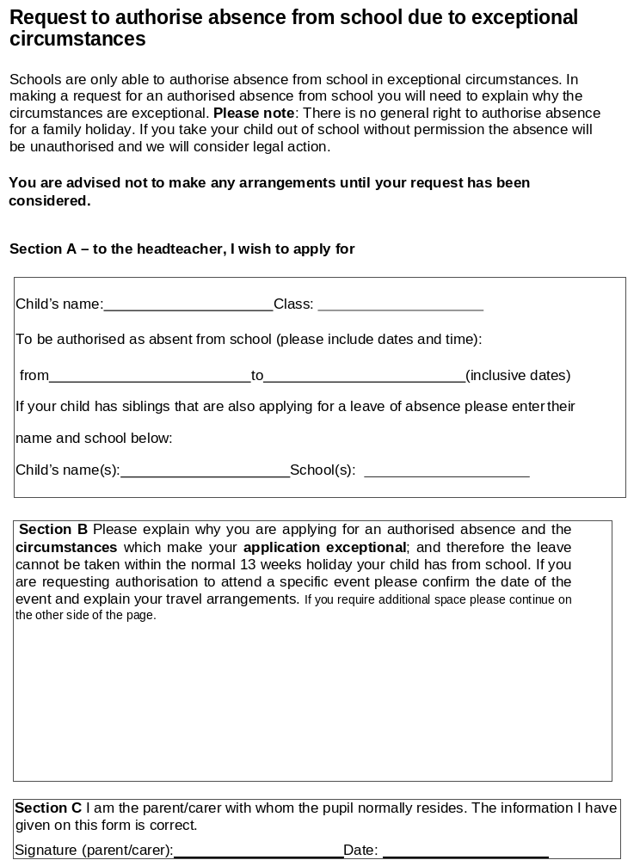

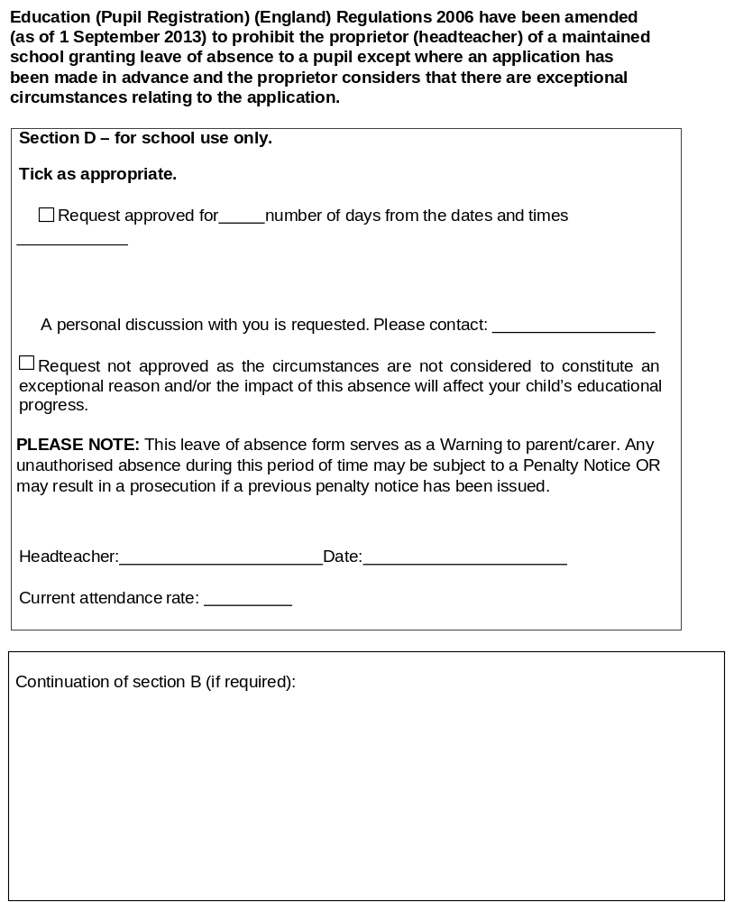

Appendix 10: Attendance Policy Quick Guide for Parents

We expect students to attend school for 100% of the academic year.

You can support your child to have excellent attendance by taking these steps:
- Ensure your child arrives on time for school every day and is ready to learn. Arriving after registration is recorded as an unauthorised absence. Students must be in school by 8.50 am.
- If your child appears to be only slightly unwell, send them in to school. We have staff who will contact you if their condition deteriorates.
- Book any medical appointments outside of school hours. If this is unavoidable, please book for as late in the afternoon as possible and inform the school of appointments in advance.
- Supply a copy of the appointment card or hospital letter if your child has an appointment during school hours.

If your child becomes reluctant to go to school or you need help, please contact the school immediately; we are more likely to be able to work together to solve any problems if we act early.

